2.public class madam
{
public static boolean isPalindrome(String string, int low, int high)
{
if (low >= high) {
return true;
}

if (string.charAt(low) != string.charAt(high)) {
return false;
}

return isPalindrome(string, low + 1, high - 1);
}

public static void main(String[] args)
{
String string = "madam";

if (isPalindrome(string, 0, string.length() - 1)) {
System.out.println("Author:J. GOPI VENKATA SAI\nSAP ID:51834677");
System.out.print("given String is Palindrome");
} else {
System.out.print("given String is Not Palindrome");
}
}
}

OUTPUT:
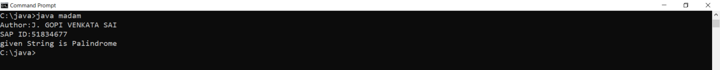

3.import java.util.*;
public class Main
{
public static void main (String[] args)
{
System.out.println("Author :J.GOPI VENKATA SAI \n SAP ID:51834677");
int count=0;
int rem=0 ;
Scanner sc=new Scanner(System.in);
System.out.println("enter a number :");
int n= sc.nextInt();
while(n>0)
{
rem=n%10;
if(rem%2!=0)
{
count++;
}
n=n/10;

}
System.out.println("no of odd digits in number are : "+count);

}
}

OUTPUT:
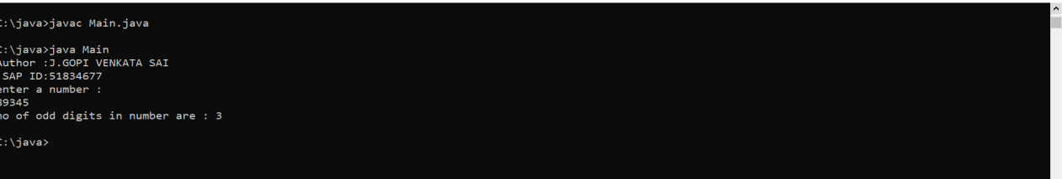

5.public class JavaExample {
public static void main(String []args) {
String str[] = { "Ajai", "vivek", "Richy", "vicky", "Manoj"};
String temp;
System.out.println("Strings in sorted order:");
for (int j = 0; j < str.length; j++) {
for (int i = j + 1; i < str.length; i++) {
// comparing adjacent strings
if (str[i].compareTo(str[j]) < 0) {
temp = str[j];
str[j] = str[i];
str[i] = temp;
}
}
System.out.println(str[j]);
}
}
}

OUTPUT:
